Arleen Pancza Graham Word Count = 480

**Gertrude Vanderbilt Whitney (1875-1942)**

Gertrude Vanderbilt Whitney,an American sculptor, art collector, philanthropist, and patron, is usually remembered as the founder of The Whitney Museum of American Art in New York. A Manhattan native, she was the great-granddaughter of the wealthy transportation industrialist, Cornelius Vanderbilt (1794-1877). In 1896, she married the affluent Harry Payne Whitney (1872-1930), an heir to an oil, tobacco, and banking fortune and descendent of Eli Whitney, who invented the cotton gin. She participated in many philanthropic activities in her lifetime, including sponsoring the American Ambulance Field Hospital in France during World War I. Though participating in society events, she preferred the company of the bohemian artists who frequented the Greenwich Village area of lower Manhattan. In 1907, she established her own studio on MacDougal Alley in the Village. In 1914, she bought a townhouse at 8 West 8th Street, to which she added adjoining townhouses that became known as the Whitney Studio Club. It was a gathering place where artists could socialize, study, sketch, and exhibit their work. It was during this period that she first employed Juliana Rieser Force (1876-1948) as her secretary. An able administrator, Force later became the founding director of the Whitney Museum at that location.

Whitney’s travels in Europe in 1901 sparked her own latent interest to create art. She began to study sculpture seriously, first in New York at the Art Students League and later with Auguste Rodin in Paris. Her large public monuments commemorate historical events and individuals such as Peter Stuyvesant, Christopher Columbus, and the Founders of the Daughters of the American Revolution. During the 1920s, Whitney formed her own collection of American art. As in her sculpture, her personal taste was for artists working in a figurative or social realist style. As her personal collection grew, so too did the need to adequately house it. In 1929, she instructed Force (by then the managing director at the Whitney Studio Club) to offer over five hundred works by largely uncelebrated American artists, along with the funds to construct a wing to house them, to the Metropolitan Museum of Art. The proposed gift was rejected by the traditionally minded director. As a response to this affront, Whitney immediately began plans to found a museum for American art. It opened in November 1931; many of these same rejected pieces became the foundation of the museum’s collection. The following year, the first of what became regular exhibitions of work by emerging American artists was held. By the 1960s, this had evolved into the Whitney Biennial, an influential venue for living artists who continue to benefit from Gertrude Vanderbilt’s legacy.

**References and Further Reading:**

Berman, Avis (1990) *Rebels on Eighth Street: Juliana Force and the Whitney Museum of American Art.*

New York, Athenaeum Press.

Biddle, Flora Miller (2012) *The Whitney Women and the Museum They Made: A Family Memoir.*

New York, Skyhorse/W.W.Norton Publishing.

Friedman, B.H. (1978) *Gertrude Vanderbilt Whitney: A Biography*. Garden City, N.Y., Doubleday.

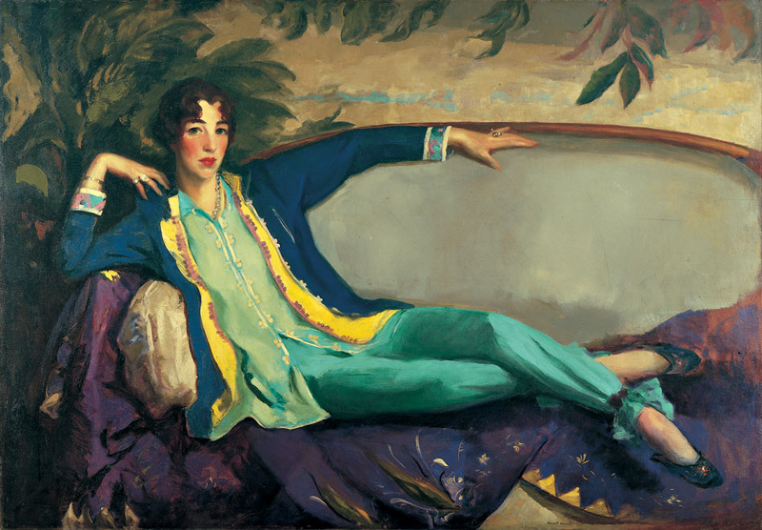

*Gertrude Vanderbilt Whitney*, Robert Henri, 1916, The Whitney Museum of American Art

http://whitney.org/Collection/RobertHenri/86703